**Scientific Computing Project**

Goal: Create a program that will solve the Poisson equation

$$\frac{d^{2}u}{dx^{2}}+\frac{d^{2}u}{dy^{2}}=-F\left(x,y\right)$$

The domain of interest is the rectangle:

$$0<x<2π 0<y<2π$$

And the boundary conditions:

$$u\left(x=0,y\right)=y^{3}, u\left(x=2π,y\right)=y^{2}\cos{y}$$

$${\left.\frac{du}{dx}\right|}_{y=0}=0 u\left(x,y=2π\right)=$$

$$F\left(x,y\right)=\cos\left(\frac{x+π}{2}\right)\sin\left(\frac{y}{2}\right)$$

Since we are working with second derivative elements, we will use the five point approximation:

$$-F\left(x,y\right)=\frac{u_{j-1,k}-2u_{jk}+u_{j+1,k}}{Δx^{2}}+\frac{u_{j,k-1}-2u_{jk}+u_{j,k+1}}{Δx^{2}}$$

We will use the commonly used special case where $Δx=Δy=Δ$, so:



$$u_{j-1,k}+u_{j+1,k}+u_{j,k-1}+u_{j,k+1}-4u_{jk}=Δ^{2}\left(-F\left(x,y\right)\right)$$

$${\left(2π\right)}^{3}+\frac{x}{2π}{[(2π)}^{2}cos \left(2π\right)-{\left(2π\right)}^{3}]$$

$$y^{3}$$

$$y^{2}cos y$$

$$2π$$

$$2π$$

$$0$$

$$0$$

$${\left.\frac{du}{dy}\right|}_{y=0}=0=0$$

Website help:

Youtube: Solving 2D poisson equation in Matlab



TO DO:

* Decide the discretization length

Notes

* Create 5 vectors LD (lower diagonal), D (Diagonal), UP (Upper diagonal), two subdiagonals
* Choose discretization length

Trial One

Set up a simple 2d poisson problem with simple Dirichlet boundary conditions

7

5

10

|  |  |  |  |  |  |  |  |  |  |  |  |
| --- | --- | --- | --- | --- | --- | --- | --- | --- | --- | --- | --- |
|  |  |  |  |  |  |  |  |  |  |  |  |
|  |  |  |  |  |  |  |  |  |  |  |  |
|  |  |  |  |  |  |  |  |  |  |  |  |
|  |  |  |  |  |  |  |  |  |  |  |  |
|  |  |  |  |  |  |  |  |  |  |  |  |
|  |  |  |  |  |  |  |  |  |  |  |  |
|  |  |  |  |  |  |  |  |  |  |  |  |
|  |  |  |  |  |  |  |  |  |  |  |  |

2

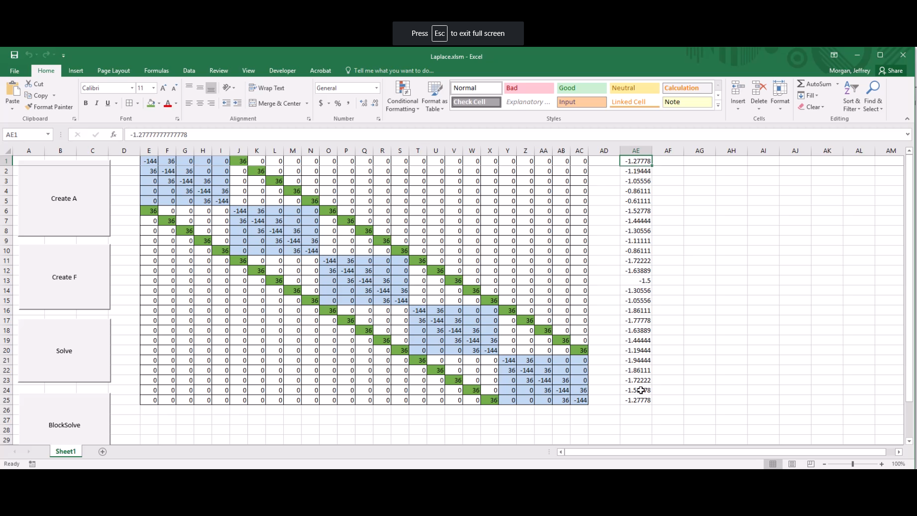

Optimize by forming the inner matrix and then adding to whole matrix.

Also store green diagonal values and add them to whole matrix